**Revise Unit Test Cases**

**Module Description**

Following the peer review, this module will now give you the opportunity to update your testing work products.

**Scenario**

As the author of the reviewed work product, you will review the Peer Review Feedback Form and make the changes needed to the work product and document those changes by updating the Peer Review Feedback Form.

You will meet again (if required) with the reviewer to discuss which items were fixed (closed status) and which were not (rejected status). The rejected fixes will have a documented reason why the fix was rejected and the rejection must be approved and documented by the reviewer.

The updated work products and feedback forms are checked in by the author. The team will track the status and performance of the peer review process to enable them to provide a status to the leadership.

**ADM Activity Context Diagram**

* Application > 4100 Build Application > 4183 Create Unit Tests

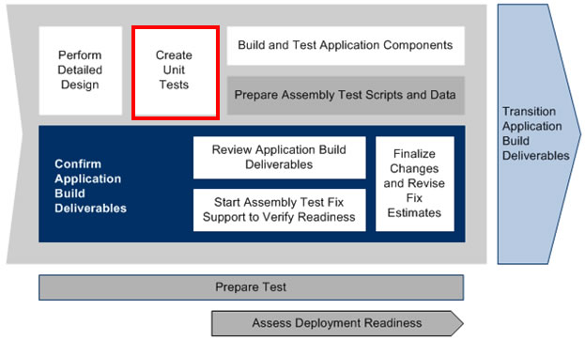

**Roles**

|  |  |  |  |
| --- | --- | --- | --- |
| **Role** | **ADM Task** | **ADM Responsibility** | **Description** |
| Team Lead | 4183 - Create Unit Tests | Primary Performer | Tracks the status and performance of the Peer Reviews. |
| Developer | 4183 - Create Unit Tests | Primary Performer | Makes reviews or rejects updates to work products based on the results in the Peer Review Feedback Form.  Makes updates to the Peer Review Feedback Form. |

**Participant Instructions**

1. Launch the [Master Practice Primer](https://accenture.desire2learn.com/content/enforced/9406-Pending/NCCC_Project_Work_Products/1_PM/ADF_Java_2_0_Master_Practice_Primer_REF.docx?_&d2lSessionVal=YnoL4daZGC8ne2RyGf0cWMrk8) document.

2. Launch the following templates:

[Peer Review Feedback](https://accenture.desire2learn.com/content/enforced/9406-Pending/W3_Participant_Materials/Module_33/PeerRvwFdbk_FERS_R1_TMPL.xlsx?_&d2lSessionVal=YnoL4daZGC8ne2RyGf0cWMrk8)

[Unit Test Scenarios](https://accenture.desire2learn.com/content/enforced/9406-Pending/W3_Participant_Materials/Module_33/Unit_TestScen_FERS_R1_TMPL.xlsx?_&d2lSessionVal=YnoL4daZGC8ne2RyGf0cWMrk8)

[Unit Test Conditions and Expected Results](https://accenture.desire2learn.com/content/enforced/9406-Pending/W3_Participant_Materials/Module_33/Unit_TestCond_FERS_R1_TMPL.xlsx?_&d2lSessionVal=YnoL4daZGC8ne2RyGf0cWMrk8)

[Unit Test Cycle Control Sheet](https://accenture.desire2learn.com/content/enforced/9406-Pending/W3_Participant_Materials/Module_33/Unit_TestCycle_FERS_R1_TMPL.xlsx?_&d2lSessionVal=YnoL4daZGC8ne2RyGf0cWMrk8)

3. Open the Peer Review Section.

4. Read the Fix and Follow-Up process for details on the steps to complete following the Peer Review meeting.

**Hints and Tips**

1. Update the Status and comments in the Peer Review Feedback Form. This is proof of due diligence that you have followed the project's quality standards/procedures by thoroughly fixing the work product or providing a reason not to.

2. Don't be afraid to question the changes—some feedback does get rejected when it makes sense.

3. Don't take the feedback personally. It is designed to improve the quality of the deliverables for the future and remember, the more changes, the more you will improve.